**SIT 401:ICT PROJECT MANAGEMENT**

**CONTINUOUS ASSESSMENT TEST**

1. Project schedules are a key aspect of project management. An ICT project had the following activities.

|  |  |  |
| --- | --- | --- |
| **Activity** | **Predecessor** | **Duration in Weeks** |
| A | - | 5 |
| B | - | 7 |
| C | A | 6 |
| D | B | 5 |
| E | B | 4 |
| F | D, E | 8 |
| G | C, F | 8 |
| H | D | 6 |
| I | G, H | 3 |

Required:

1. Draw the necessary diagram and calculate the critical path for the project.
2. Critically evaluate the impact each of the following techniques on the duration of a project:
3. Critical Chain Scheduling
4. Levelling of resources
5. Crashing of tasks
6. Describe how the a scope of an IT project can be controlled
7. Answer the questions that follow based upon the following diagram and activity durations

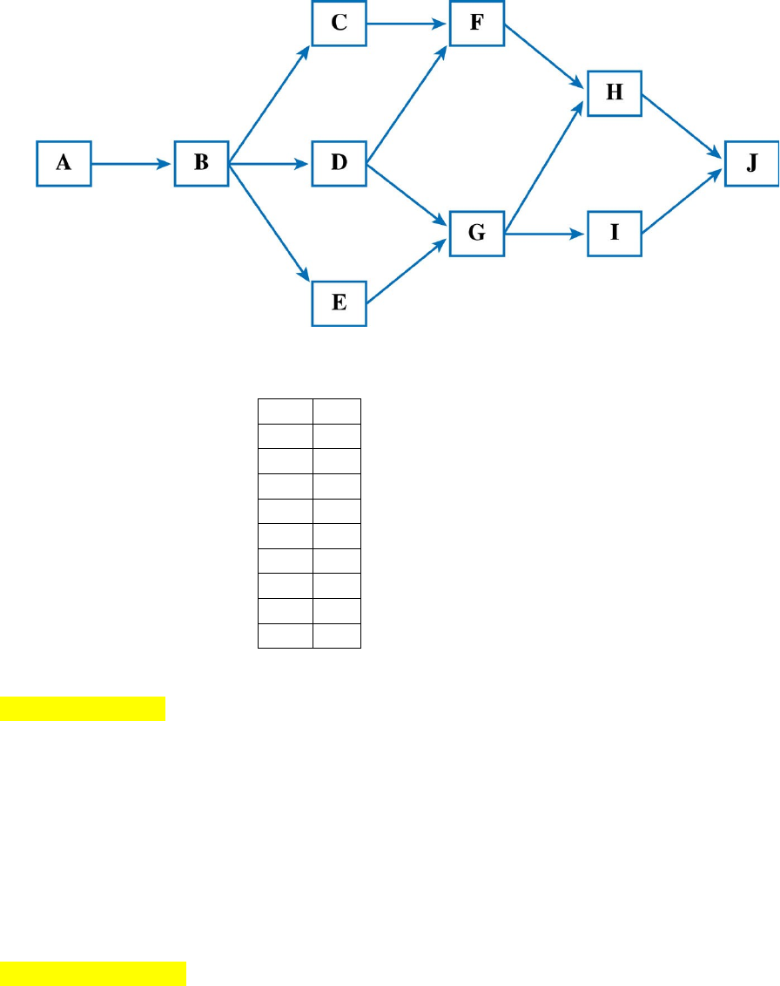

|  |  |  |  |  |  |  |  |  |  |  |
| --- | --- | --- | --- | --- | --- | --- | --- | --- | --- | --- |
| **ACTIVITY** | **A** | **B** | **C** | **D** | **E** | **F** | **G** | **H** | **I** | **J** |
| **DURATION** | **2** | **5** | **4** | **3** | **1** | **4** | **3** | **5** | **5** | **1** |

1. Calculate the critical Path***(show your workings )*** (4 marks)
2. Illustrate from the above diagram the tasks ***A*** that have the following dependencies

(4 marks)

1. Finish-To-Start (FS)
2. Start-To-Start (SS)
3. Finish-To-Finish (FF)
4. Software System (O).
5. The following table defines the various activities of a small project and their durations.

|  |  |  |
| --- | --- | --- |
| **A** | **-** | **1** |
| **B** | **A** | **4** |
| **C** | **A** | **2** |
| **D** | **A** | **6** |
| **E** | **B** | **2** |
| **F** | **C** | **5** |
| **G** | **F,D** | **3** |
| **H** | **E,G** | **6** |
| **I** | **D,F** | **1** |
| **J** | **H,I** | **2** |
| **K** | **J** | **8** |
| **L** | **K** | **2** |

**Required:**

1. Draw a network diagram showing the EST and LST for each activity.
2. What is the length of the project
3. Differentiate between a PERT chart and Gantt Chart using an example
4. You have been hired as an ICT project consultant and the client requires you to determine the projected financial value of one of their projects, Discuss three methods you will use.
5. Critically evaluate how the Program Evaluation and Review Technique (PERT)

can be used for project time management.